

Vectury

OpenTrust Kit

OpenTrust version 4.30

11 January 2011 | Version: 1.0

Summary
Introduction 3
Installation 4
Installation with administration privileges 5
Degraded procedure: installation without administration privileges 7
Proxy settings 9
Browser configuration 11
OpenTrust SCM client user guide 16
Enrollment of a token 18
Change PIN code 20
Unlock a token 22
Renewal of the certificate on the token 24
Show certificates 26
Update 27

Introduction
The Vectury OpenTrust kit installs the necessary components for the use of Vectury tokens on a PC.
The kit contains:
- The Client OpenTrust SCM v4.3.0 application
- The Vectury authority chain
- The eToken PKI Client driver 5.1.SP1 5400
- The Athena Card Reader driver 2.9.0.0

 Compatible Operating Systems
- Microsoft Windows XP 32 bits
- Microsoft Windows Vista 32 bits
- Microsoft Windows 7 32 bits and 64 bits
- Microsoft Windows 2003

 Compatible browsers
- Internet Explorer 7 and 8
- Mozilla Firefox 3.5 and 3.6

Installation

The OpenTrust Vectury kit 4.3.0 rev 119307 is available at https://mdx.dcs.renault.com/mdx/data/SCMv430r119307/vectury-scm-setup-r119307.exe

The kit requires administration privileges on the PC in order to install the eToken driver, as well as the OpenTrust SCM client application for all users (and also de-install the previous version possibly installed on the PC).

Without administration privileges, the kit only installs the OpenTrust SCM client application in the context of the user. If the PC did not have any eToken driver previously installed, the OpenTrust application cannot work (the installation kit checks if a relevant eToken driver is installed, and if not, it displays a pop-up and stops the installation).

Installation with administration privileges

➔ If an eToken driver and/or the SCM application are already installed on the PC, they will be automatically removed prior to the installation of the new kit.

➔ The installation requires administration privileges. Nonetheless, for users without administration privileges, a degraded procedure has been defined, for emergency cases only: see paragraph “Degraded procedure: installation without administration privileges”.
➔ Before installation, unplugged all tokens/cards.

To launch the installation, just execute the file vectury-scm-setup-r119307.exe and follow the steps shown below.
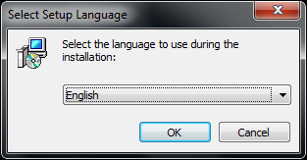 | Choose the language and click OK.
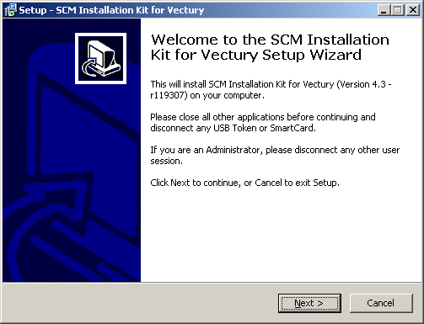 | Follow the instructions: close all active applications and check that no token is connected to the PC.  Then click on “Next”.
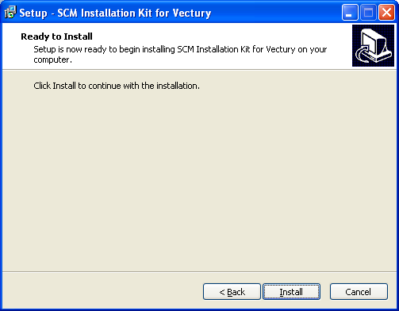 | Click on “Install” to start the installation.
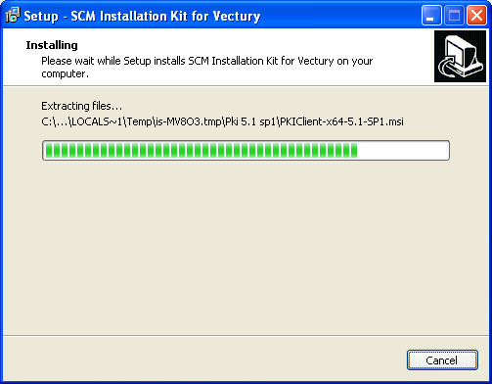 | A progress window appears.

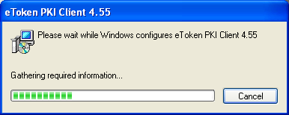  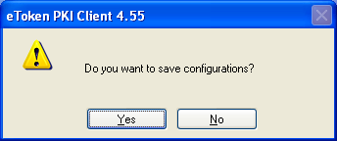 | If the kit or a previous version is detected on the PC, it is automatically removed.  During the de-installation, a dialog box will ask you if you wish to save the configuration of the previous version (proxy settings and SCM client language).
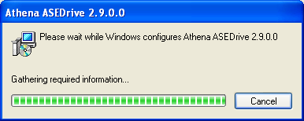  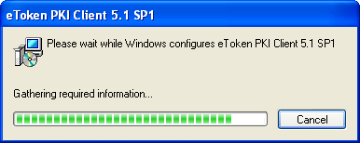  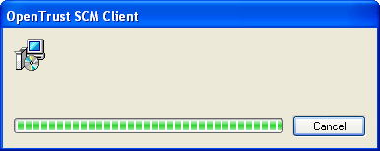 | Three additional progress windows will consecutively appear (progress of installation of eToken driver, Athena card reader, and OpenTrust SCM Client application).
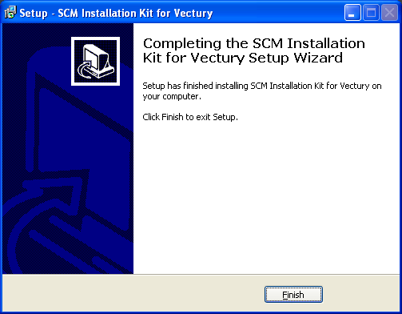 | The window will appear at the end of the installation process: click “Finish” to close the window.

➔ Next step: go to “Proxy settings” chapter to complete the installation.

Degraded procedure: installation without administration privileges

A degraded procedure has been defined for emergency cases: users who need to administrate their token immediately (token locked or last day for renewal, or certificate expired), but they don’t have administration privileges on their PC.
This procedure should be applied only if no system administrator is available, and no PC has the last OpenTrust SCM client installed in the neighbourhood.
Without administration privileges, the kit cannot install the eToken driver. As a consequence, this procedure requires that a previous kit had already been installed on the PC (kit downloaded before February 2011), so that an eToken driver is already present on the PC (the new kit can work with previous eToken drivers version 4.5 or newer).
➔ The installation without administration privilege is possible only if an eToken driver has already been installed on the PC, with version 4.5 or newer (kit published after June 2007): the kit checks this pre-requisite, and if no compliant eToken driver is detected, the kit stops the installation.
➔ Without administration privileges, the old version of the client is not de-installed: the user has to pay attention to which version of the client is launched.
➔ Without administration privileges, the client is only installed in the context of the user. Each other user of the PC will have to go through the same installation procedure.
➔ Before installation, unplugged all tokens/cards.

To launch the installation, run the file vectury-scm-setup-r119307.exe and follow the installation sequence described below.
Choose the language and click “OK”.
Follow the instructions: close all active applications and check that no token is connected to the PC.
Then click on “Next”.
.
Click on “Install” to start the installation.

The window will appear at the end of the installation process : click “Finish” to close the window

Proxy settings
If the access to Internet requires a proxy, proxy settings must be defined in the OpenTrust SCM Client.
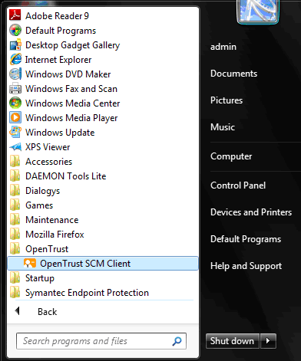 | Launch the OpenTrust SCM Client from the start menu:  Start -> All programs -> OpenTrust -> OpenTrust SCM Client.
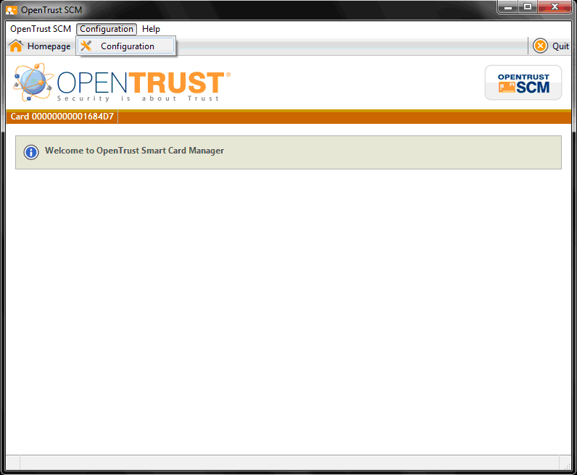 | Click on the menu item ‘Configuration’
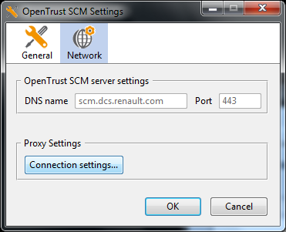 | Choose the tab “Network”, and click on “Connections settings…”
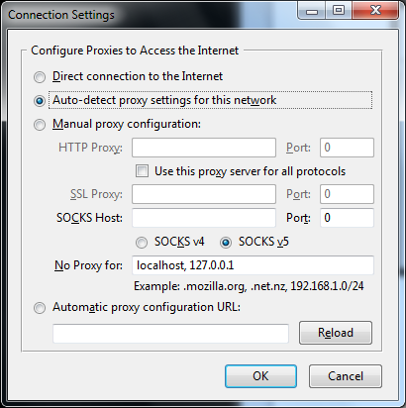 | Enter the relevant proxy settings, click “OK”, and close the OpenTrust SCM Client so that parameters are taken into account.

➔ Next step: go to “Browser configuration” chapter.

Browser configuration

Internet Explorer

➔ In most cases, Internet Explorer is already present on the PC before the OpenTrust kit is installed, and no configuration is required.

If Internet Explorer is installed or re-installed after the installation of the OpenTrust SCM kit, the “Alliance Root CA” authority needs to be declared again in the browser, by following the procedure described below.

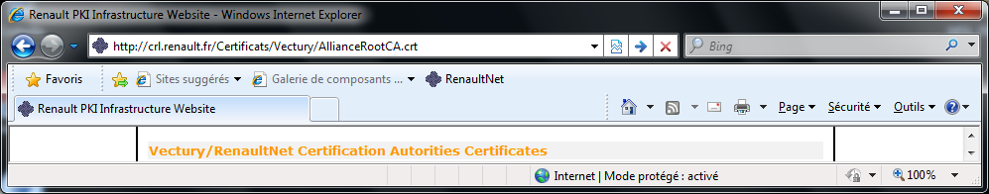 | In Internet Explorer, enter the URL  http://crl.renault.fr/Certificats/Vectury/AllianceRootCA.crt
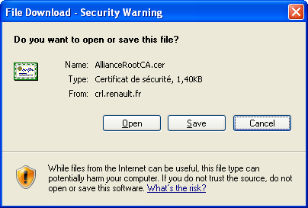 | Click on “Open”.
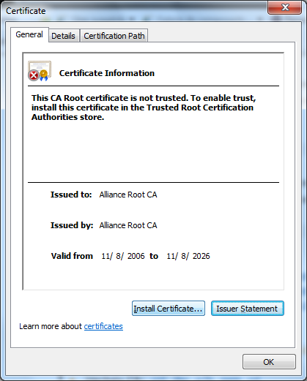 | Click on “Install Certificate…”
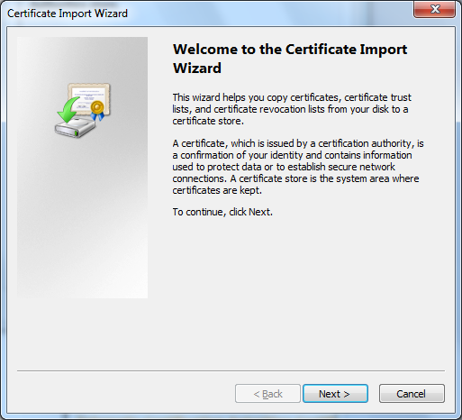 | Click on “Next”.
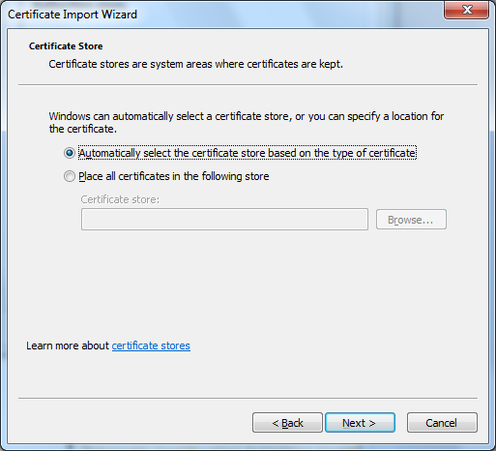 | Click on “Next”.
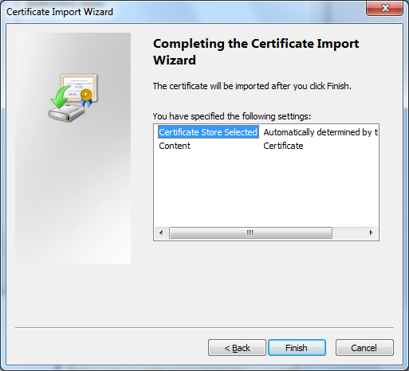 | Click on “Finish”.
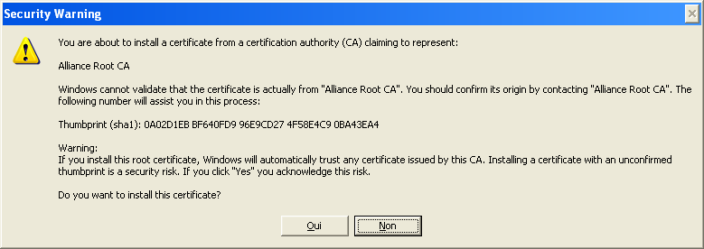 | Click on “Yes” to trust the authority “Alliance Root CA”.
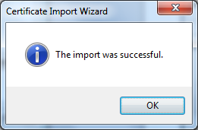 | Click on “OK”.

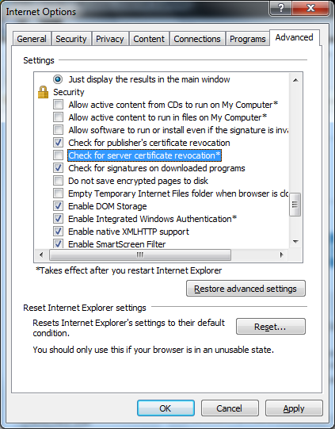 | Since IE8 the box «Check for server certificate revocation" can be unchecked to speed the authentication.

Firefox
➔ The installation of the OpenTrust SCM kit doesn’t configure FireFox, it must be done manually.

The OpenTrust kit doesn’t update the Firefox browser configuration. The eToken driver must be declared in Firefox as detailed below.

Installation of the security device (eToken driver)
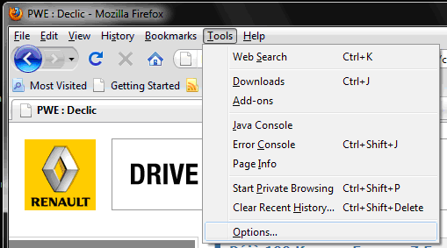 | Launch Firefox.  Select menu “Tools” / “Options…”.
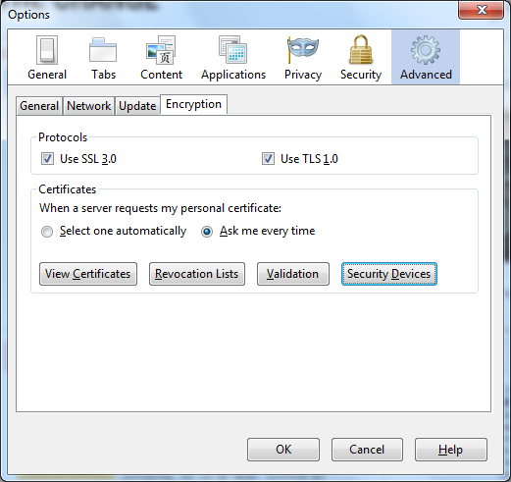 | Select tab “Advanced”.  Select tab “Encryption”  Click on “Security Devices”
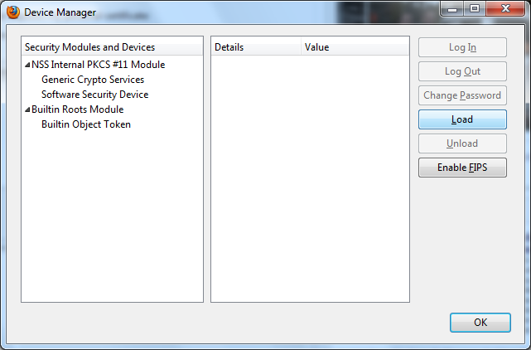 | Click on “Load”.
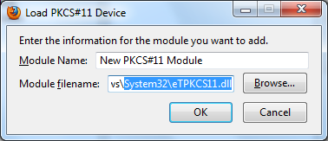 | Enter “Aladdin eToken” in the field “Module name”  Enter « c:\windows\system32\etpkcs11.dll » in the field “Module filename”.  Click on “OK”.  Remarque : for Windows 200x, the module file name is « c:\winnt\system32\stpkcs11.dll »
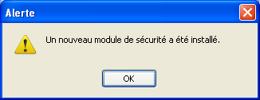 | Click on “OK”.

Installation of the “Alliance Root CA” authority
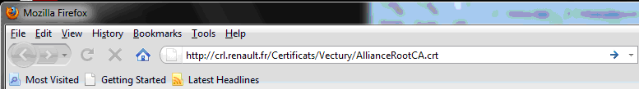 | In Firefox, enter url  http://crl.renault.fr/Certificats/Vectury/AllianceRootCA.crt
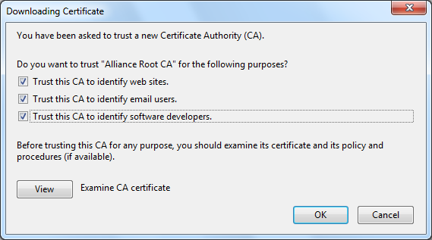 | Check the 3 boxes to trust the authority and click on “Ok”.

OpenTrust SCM client user guide

The OpenTrust SCM client is the application that must be used to manage the Vectury tokens (enrolment, renewal, unlock, change PIN code).

 The OpenTrust SCM client allows following actions on the tokens:

Contextual actions (availability of the action depends on the token state)
- Enrolment (blank or recycled token)
- Token PIN code change (token with valid certificate)
- Token unlock (locked token with valid certificate)
- Token renewal (token with valid certificate, which end date is near)

Non contextual action (independent of the token state)
- Display certificate present on the token

OpenTrust SCM client interface
The OpenTrust SCM client can be launched from the Start menu :
Start -> All programs -> OpenTrust -> OpenTrust SCM Client

Or
Directly by clicking on the icon  if available

Contextual menu, displays available actions according to the token state, among:
- Card Self-enrolment
- PIN code change
- Online unlock
- Renewal
Generic menu bar of the client:
- View certificates
- Configure the client
- Display version
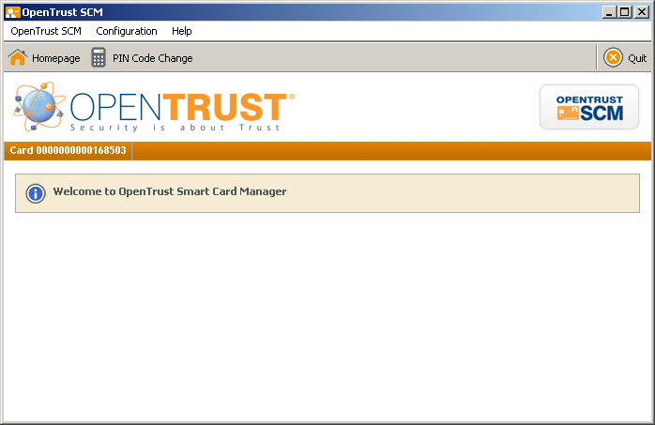
Serial number of the inserted token
Display area about on-going actions (also used to enter information like PIN code, …).
➔ If an update is available on the server for the client, a message indicates the progress of the update.

Enrollment of a token

➔ The action ‘Card Self-enrolment’ is available only if a blank token or a recycled token is inserted in the PC.
If the action ‘Self-enrolment’ is not shown, it’s because the token is still linked to a user: the link must be broken with the action ‘Terminate card’ in the renault.net subscription tool.

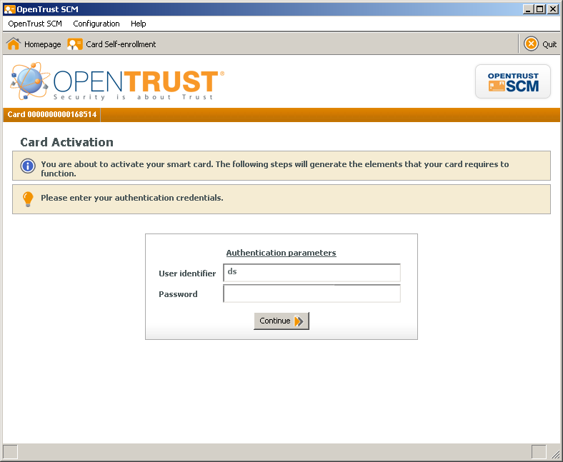 | Launch the OpenTrust SCM client (no token inserted).  The insertion of a token is automatically detected. If the token is blank or recycled, the action ‘Card Self-Enrolment’ is proposed by the client.  Fill in 2 fields :  - User identifier (user PIN)  - User password (one-shot password given by the renault.net administrator, for retrieval of the user certificate,  Then click on ‘Continue’.  ➔ The message « invalid identifier » is displayed if the user PIN or the password is not valid. Try again (verify that ‘Caps lock’ is not active for example), and if necessary, ask a new password to your renault.net administrator.
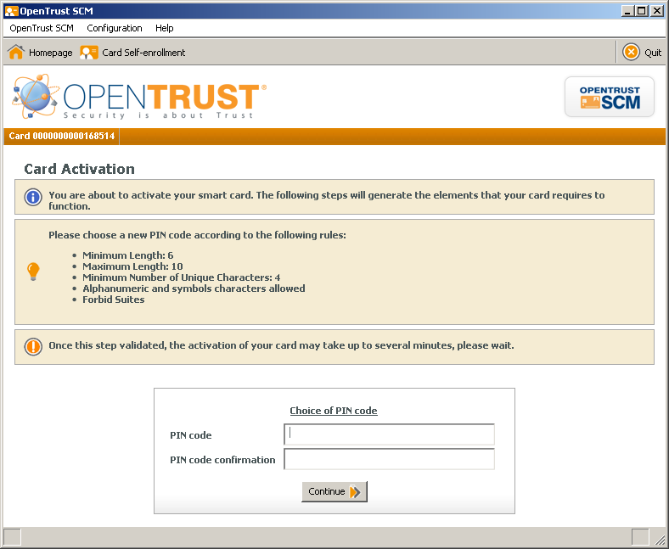 | The second step of the enrolment is the definition of a PIN code that protects the access to the token.  The PIN code is the equivalent of the code that protects the access to a bank card. It is strictly private, and must be only know by the owner of the token.  The PIN code will be asked each time the token will be used (to connect to a secured site like renault.net for example).  Enter PIN code, confirm PIN code, and click ‘Continue’.  ➔ For security reasons, the PIN code must respect the following rules :  - Length between 6 and 10 characters.  - Among the 4 categories ‘Uppercase – Lowercase – Digit – Special character’, at least 3 must be used  - No suite in the code (like ‘123’ for example)
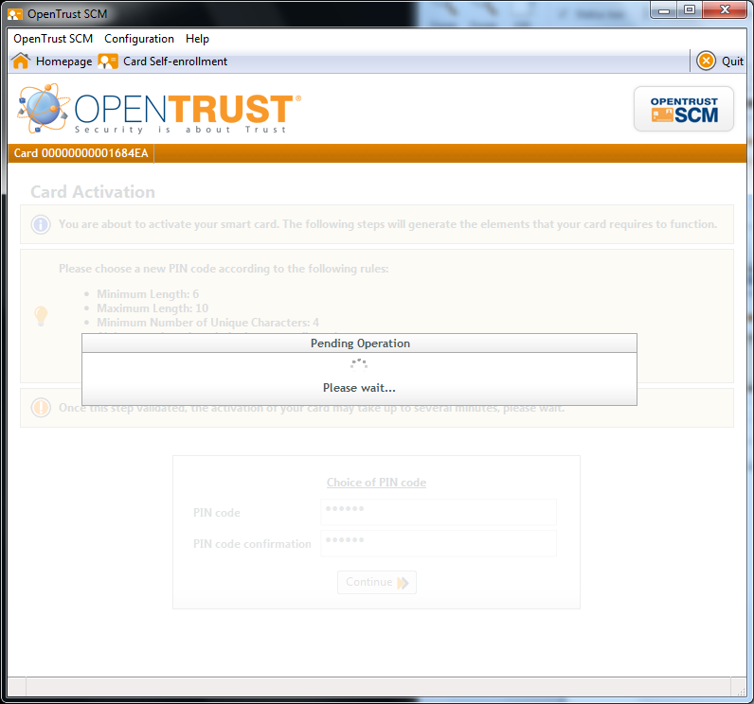 | ➔ Be careful: the generation of a client certificate (by the token) can last several minutes. DO NOT REMOVE the token before the end of the operation.  The enrolment procedure consists in several actions. The name of each action is displayed by the client during the procedure:  - Card activation  - Card cleaning  - Data generation  - Data reception  - Data import  - Validation
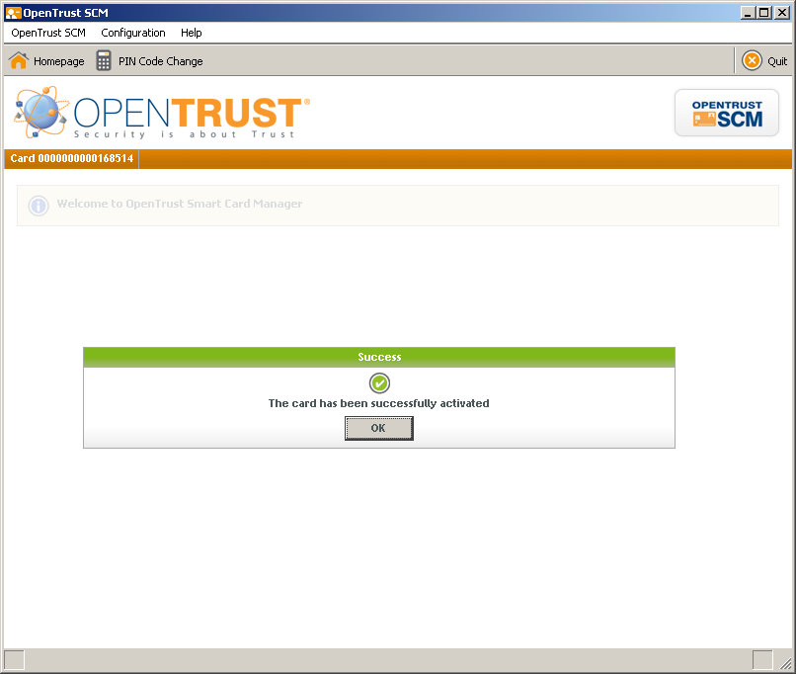 | At the end of the enrolment procedure, a success message is displayed.  The token is now active. It can be removed from the PC.

Change PIN code

➔ The PIN code is the password that protects the access to the token (similar to the PIN code of a bank card). It’s strictly confidential information that only the owner of the token should know.
The action ‘change PIN code’ allows the user to change the PIN code of his/her token.

➔ The action is available only if the token is active.

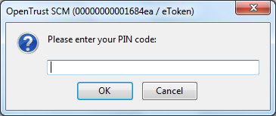  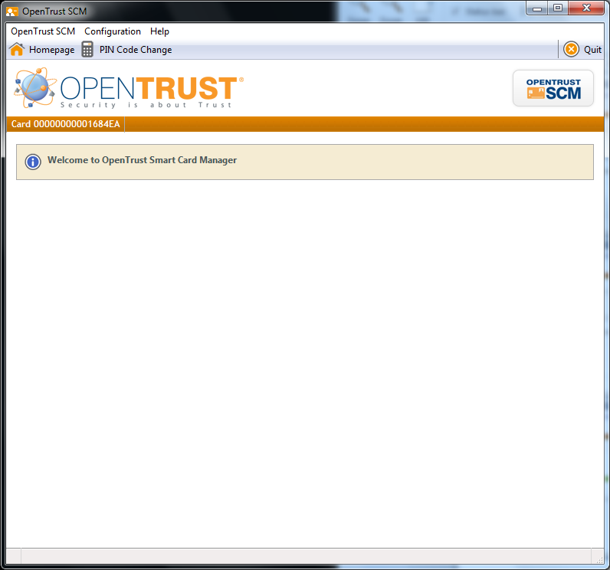 | Launch the OpenTrust SCM client.  Insert an active token.  Enter the PIN code of the token.  Click on the menu ‘Change PIN code’.  ➔ Be careful: the PIN code is case sensitive (watch out lowercases / uppercases). After 6 consecutive unsuccessful trials, the token is locked (see paragraph ‘Unlock a token’ to know how to unlock a token).
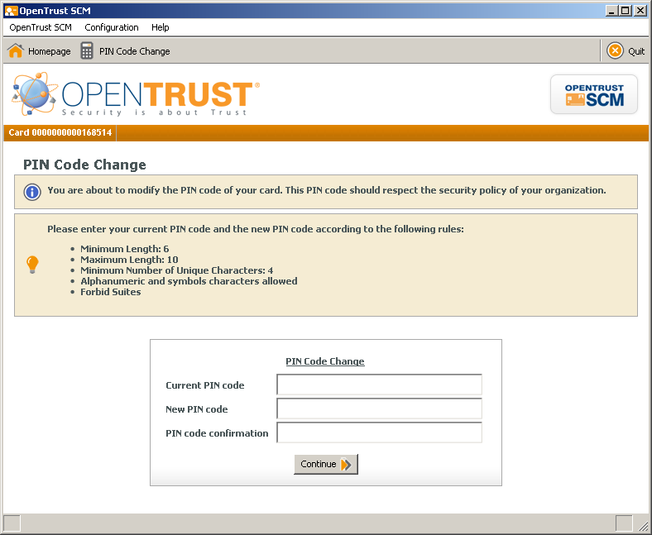 | Enter following information :  - Current PIN code  - New PIN code  - Confirm new PIN code  ➔ For security reasons, the PIN code must respect the following rules :  - Length between 6 and 10 characters.  - Among the 4 categories ‘Uppercase – Lowercase – Digit – Special character’, at least 3 must be used  - No suite in the code (like ‘123’ for example)
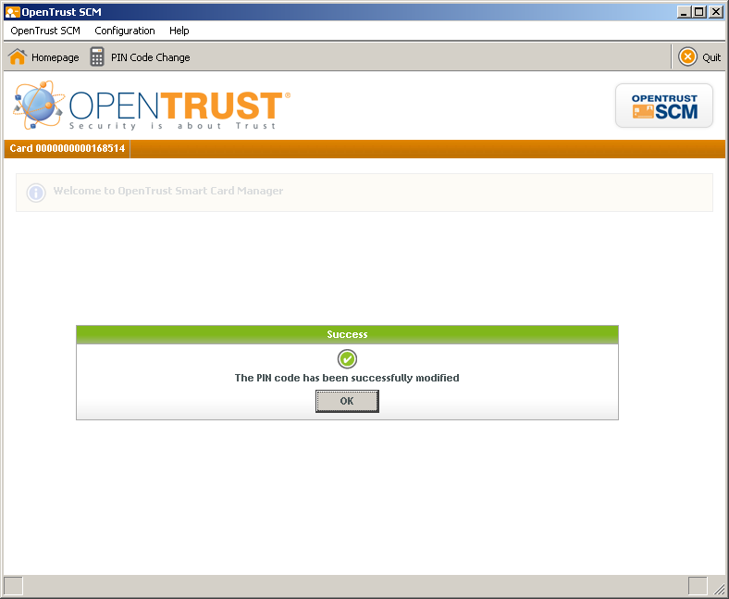 | A success message is displayed if the PIN code has been successfully changed.  The access to the token is bow protected by the new PIN code.

Unlock a token

➔ Like bank credit card that is locked after 3 consecutive unsuccessful trials of the PIN code, a token is locked after 6 consecutive unsuccessful trials of the PIN code: the token cannot be used anymore; it must be unlock to be operational again.
The first step is to ask for an unlock code to your renault.net Administrator.
Then, the action ‘Unlock token’ will appear in the OpenTrust SCM client, and it will be possible to unlock the token by following the procedure described below.

➔ The action is available only for active tokens for which an unlock code has been given by the renault.net Administrator.
➔ Be careful: if you enter 5 consecutive unsuccessful unlock codes, the token is definitively locked (it must be changed).

 | The first step consists in asking for an unlock code to your renault.net Administrator. He will need :  - The PIN and name of the user (renault.net PIN, not the PIN protecting access to the token)  - The token serial number  => The renault.net Administrator will send back an online unlock code (11 letters or digits)
Launch the OpenTrust SCM client.
Insert the locked token in the PC.
Enter any PIN code, and click ‘OK’.

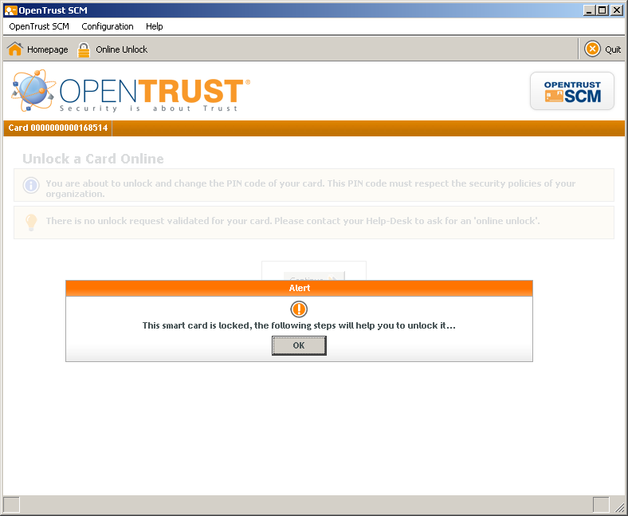 | The OpenTrust SCM client will display a message saying “the token is locked”.  Click on ‘OK’.
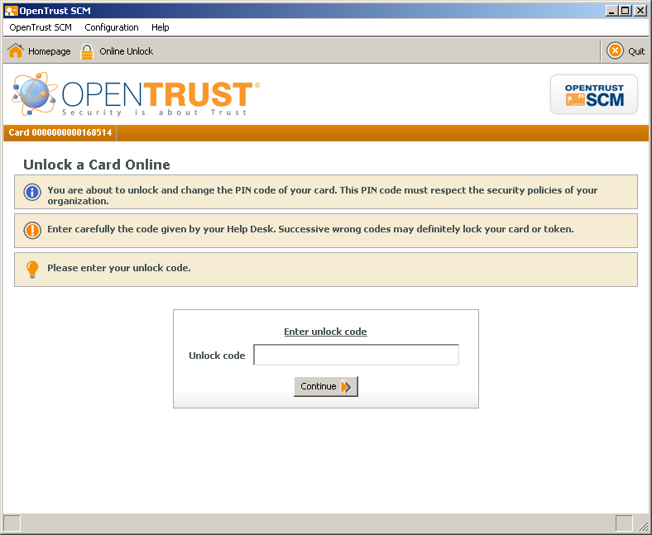 | Enter the online unlock code provided by your renault.net Administrator, and click on ‘Continue’.  ➔ The spaces in the unlock code are not significant, it’s possible not to take them into account (the spaces are added to facilitate the communication of the unlock code)  ➔ The message « invalid code » is displayed if the unlock code is not recognized by the card management system (CMS). In this case, ask your renault.net Administrator for another unlock code. If the process still fails, ask your renault.net Administrator to terminate your token, and to give you a password so that you can retrieve a new certificate (see ‘Enrolment of a token’).  ➔ Be careful: if you enter 5 consecutive unsuccessful unlock codes, the token is definitively locked (it must be changed).
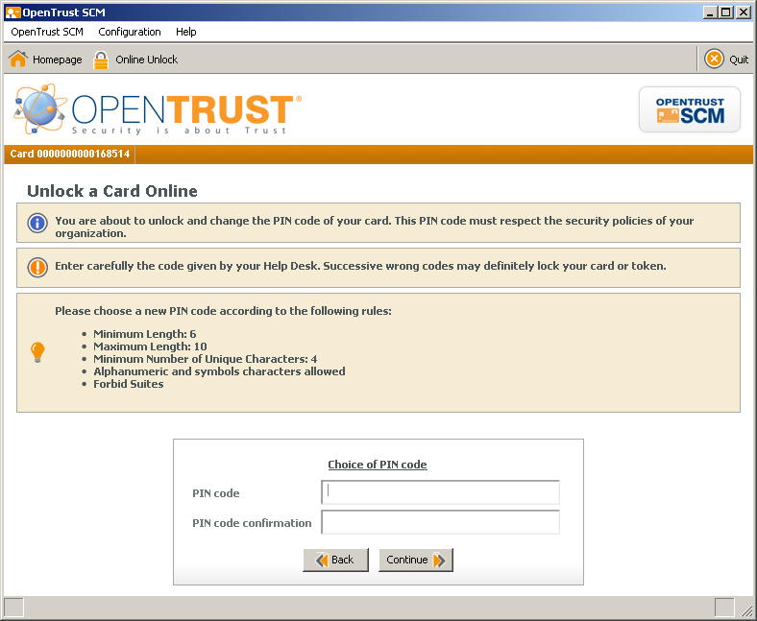 | Enter a new PIN code and confirm it, then click on ‘Continue’.  ➔ For security reasons, the PIN code must respect the following rules :  - Length between 6 and 10 characters.  - Among the 4 categories ‘Uppercase – Lowercase – Digit – Special character’, at least 3 must be used  - No suite in the code (like ‘123’ for example)
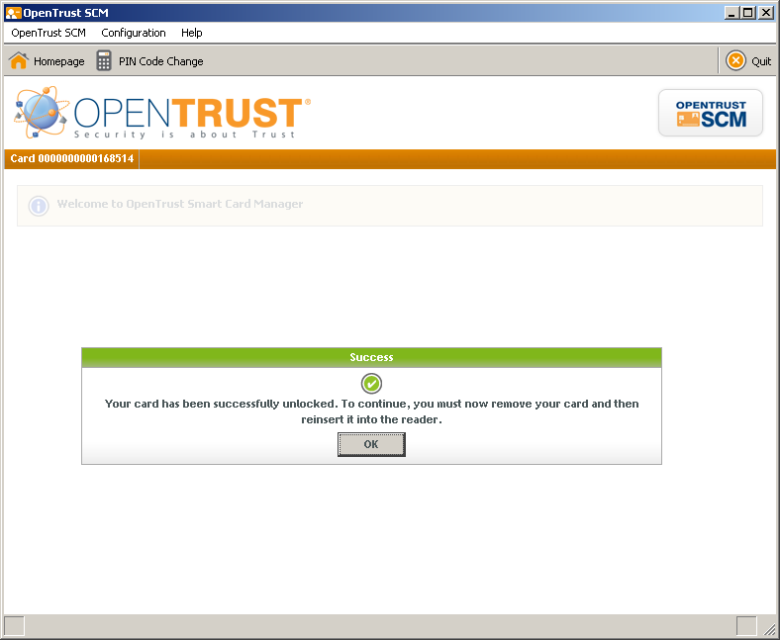 | A success message is displayed at the end of the procedure: click on ‘OK’.  The token is now protected by the new PIN code.

Renewal of the certificate on the token

The certificate hosted by the token is valid for 2 years. 5 weeks prior to its end date, the user is invited to renew the certificate (message displayed when accessing the renaul.net home page, until the certificate is renewed).
The renewal action allows a user to renew his/her certificate by his/her own, without any intervention of the renault.net Administrator.
The renewal can take place at any time between the first appearance of the message (5 weeks before the expiry date) and the expiry date.
Once the expiry date has been reached, if the certificate has not been renewed, the certificate is expired. The user must contact the renault.net Administrator so that the token is terminated, and a new procedure of enrolment can be launched to get a new certificate.

➔ The action ‘Renewal’ is available provided that :
- The token is active
- The token hosts a certificate with an expiry date taking place in the next 5 weeks
- As a consequence, the certificate hosted by the token is not expired.

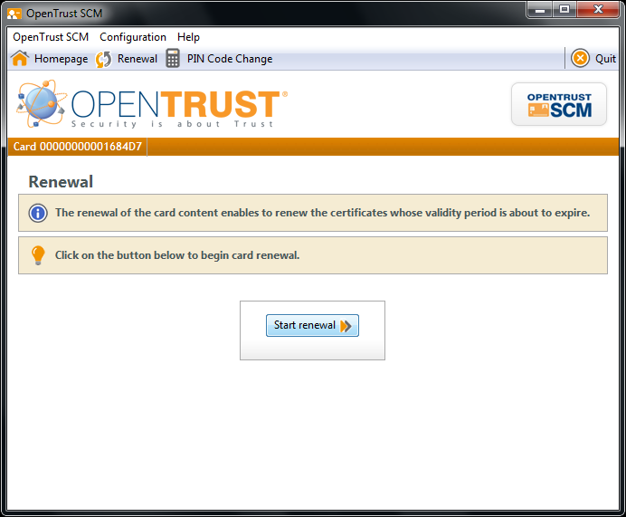 | Launch the OpenTrust SCM client.  Insert the token to renew.  Enter the PIN code protecting the access to the token.  Click ‘OK’.  Click on the button ‘Start renewal’.
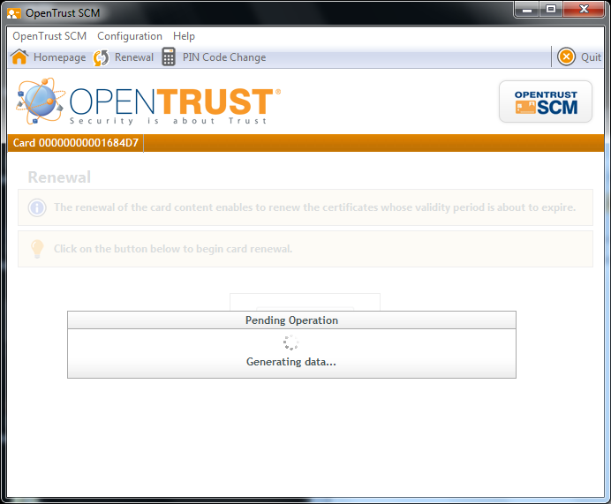 | ➔ Be careful: le renewal of the certificate can last several minutes. DO NOT REMOVE the token before the end of the procedure.  The renewal procedure consists in several actions. The name of each action is displayed by the client during the procedure:  - Card cleaning  - Data generation  - Data reception  - Data import  - Validation
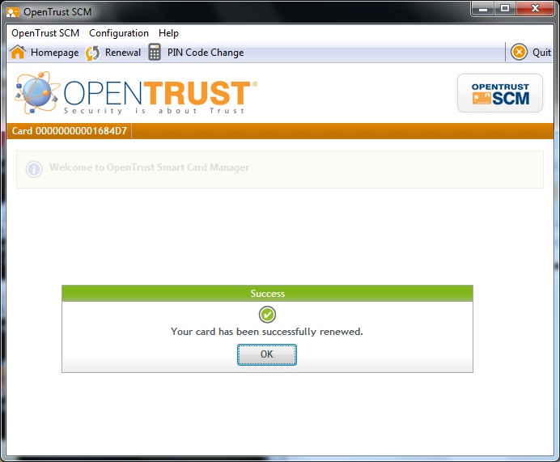 | A success message is displayed at the end of the procedure: click ‘OK’.  The certificate on the token is now renewed: the token now hosts a new certificate, valid for 2 years.  The token can be removed from the PC.

Show certificates

The action ‘Show certificates’ is always available whatever the state of the token, and can be done even if the PIN code protecting access to the token is not known.

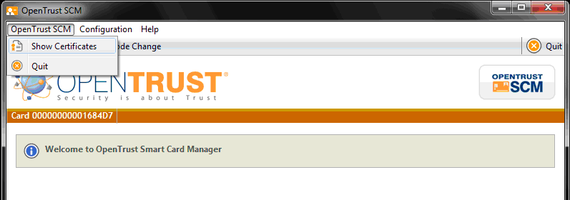 | Launch the OpenTrust SCM client.  Insert a token in the PC.  Enter or not the PIN code.  Select menu  OpenTrust SCM -> Show Certificates.  ➔ This action can be done even if the PIN code protecting access if the token is not known (click on ‘Cancel’ on the window asking for the PIN code)
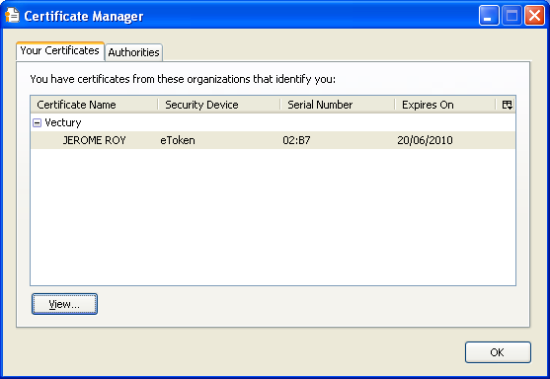 | A window will show the content of the card, and details about the certificates :  - Name of the certificate owner (active or not)  - End date of the certificate.

Update

When the application is launched, it checks for available updates on the server and automatically performs the update, if necessary.

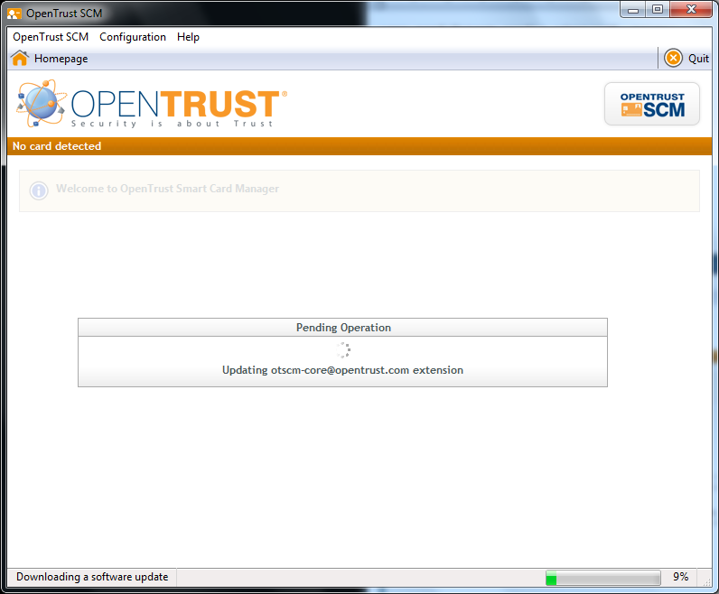 | 